Mazda, Saudi Aramco and AIST launch research project

• Well-to-wheel considerations fuel collaborative research to reduce overall CO₂ emissions
- • Project advances ‘Sustainable Zoom-Zoom 2030’ vision for technology development

Hiroshima/Leverkusen, 8 August 2018. Mazda Motor Corporation today announced the start of a joint research project with Saudi Aramco, the state-owned oil company of the Kingdom of Saudi Arabia, and Japan’s National Institute of Advanced Industrial Science and Technology (AIST) aimed at making internal combustion engines more efficient and reducing carbon dioxide emissions. The research topic focuses on developing a low-carbon fuel alongside research into internal combustion engines that use the fuel.

84% of vehicles globally will still make use of combustion engines in 2035. With the research project the three companies investigating on an effective carbon dioxide reduction and the technologies behind from a well-to-wheel perspective, considering every step in the fuel life cycle from oil well to wheels on the road. Within this project, Saudi Aramco will develop a fuel based on a refinery process that results in lower carbon dioxide emissions, and Mazda and AIST will research and develop a high-efficiency engine that runs on the fuel. The initiative supports Mazda’s multi-solution approach to reduce overall carbon dioxide emissions. The company believes it is no longer sufficient to focus solely on the tank-to-wheel phase and develop fuel-efficient engines and cars that emit low levels of carbon dioxide in road traffic.

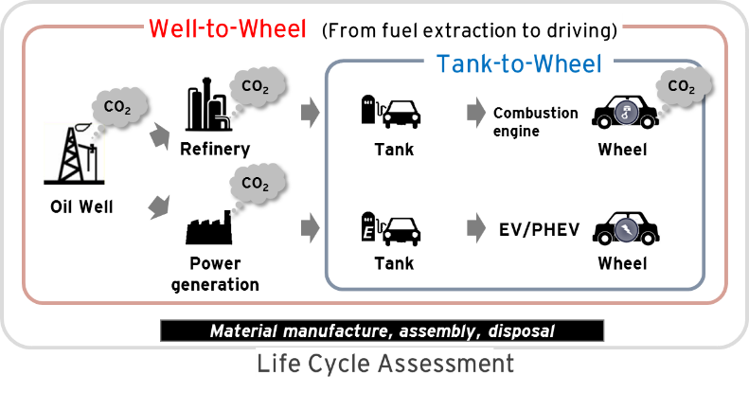
Well-to-wheel versus tank-to-wheel factors

The joint research project is in line with the company’s ‘Sustainable Zoom-Zoom 2030’ vision for technology development, announced in August 2017. The vision adopts a long-term perspective and sets out how Mazda will use driving pleasure, the fundamental appeal of the automobile, to help solve issues facing people, the earth and society.

Mazda’s participation in this research project sees the carmaker build on a long history of technology development aimed at reducing carbon dioxide emissions. The company aspires to help conserve the earth’s resources, creating a sustainable future in which people and cars coexist with a bountiful, beautiful earth. Mazda strives to protect the environment while offering cars that offer unrestricted mobility to people everywhere, combining outstanding environmental and safety performance with true driving pleasure to reach a wider range of customers globally.

‚Global transport outlook to 2050‘ by the International Energy Agency

