MAZDA RX-VISION GT3 CONCEPT

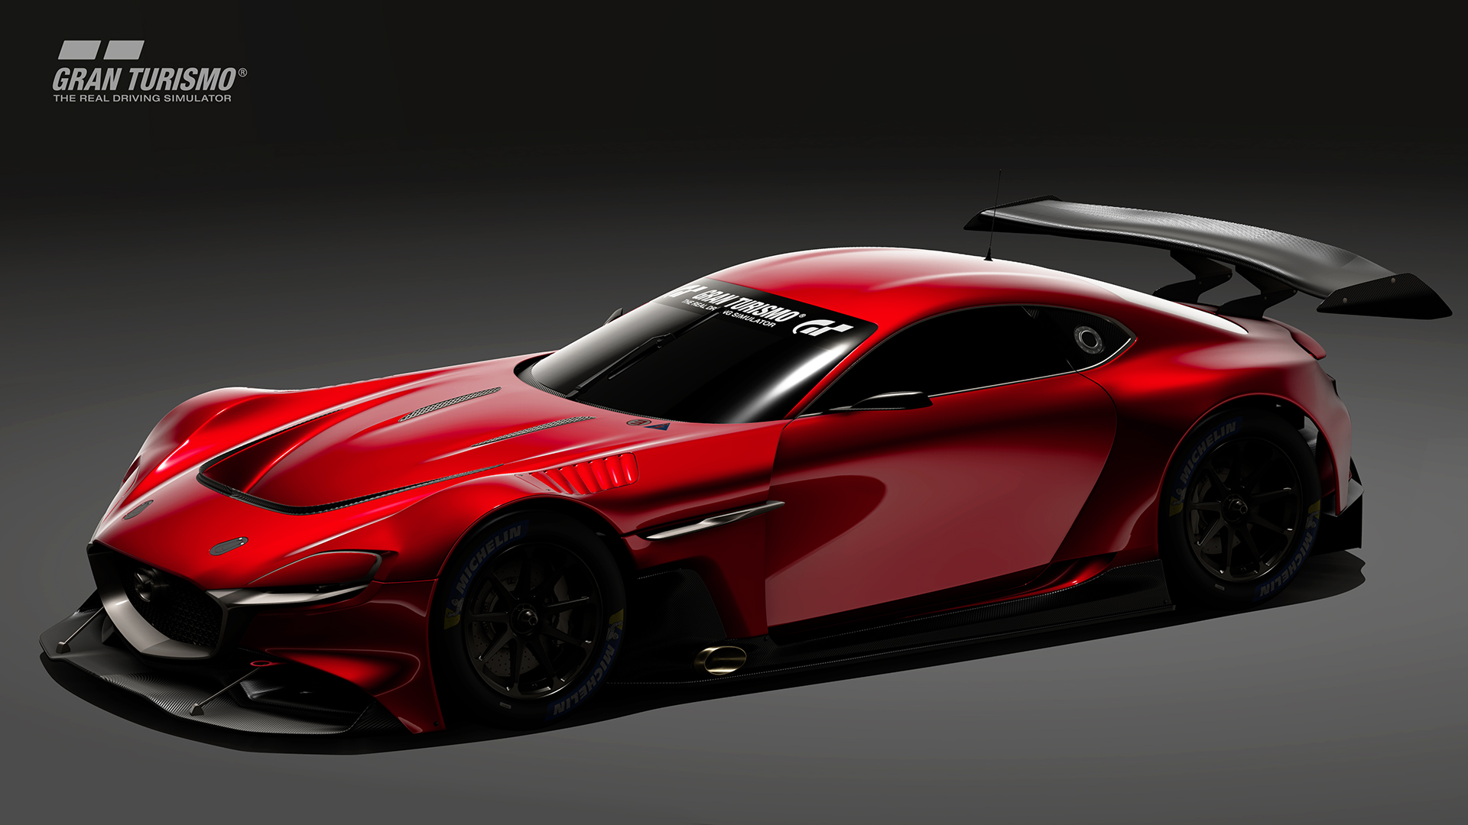
Contents
1| INTRODUCTION 3
2| MAZDA RX-VISION GT3 CONCEPT 4
3| MAZDA RX-VISION GT3 CONCEPT DESIGN STORY 6
4| GRAN TOURISMO SPORT 8
5| FIA GRAN TURISMO CHAMPIONSHIP 9
6| GRAN TURISMO AND MAZDA 10
7| MAZDA MOTORSPORTS HERITAGE 11
8| Major Mazda vehicles that appear in the Gran Turismo series 15
9| CONTACTS 16

- INTRODUCTION
Mazda recently became an official partner to the 'FIA Gran Turismo Championship', which is competed using Gran Turismo SPORT for Sony Interactive Entertainment’s (SIE) PlayStation®4. At the same time, it revealed the Mazda RX-Vision GT3 Concept virtual race car jointly developed by Polyphony Digital and Mazda. Players from around the world who enjoy Gran Turismo SPORT will be able to drive this car on all of the game's set courses from Friday 22nd May 2020.
Gran Turismo SPORT is certified and promoted by the FIA (Fédération Internationale de l'Automobile) as an official platform of digital motor sport and, by supporting the 'FIA Gran Turismo Championship' as an official partner, Mazda has obtained seed rights to participate in the tournaments scheduled to be held worldwide in the 2020 season. Gran Turismo SPORT players who use Mazda vehicles, such as the RX-Vision GT3 Concept, will have the opportunity to participate in the world final.
Mazda is aiming to strengthen its fan base by introducing the pleasure of competitive driving to a wider range of people who love digital motor sport. The company is also considering projects that will enable individuals to jump from the virtual world to the real (participatory motorsports, etc.) in an effort to attract fans who hope to enjoy driving a real car in the future and would like to participate in actual world motorsports.
- MAZDA RX-VISION GT3 CONCEPT

Overview of the virtual RX-VISION GT3 CONCEPT race car
The RX-Vision GT3 Concept is a virtual race car that appears in Gran Turismo SPORT. Based on the Mazda RX-Vision, the car is modified in accordance with FIA GT3 race car regulations. The base Mazda RX-Vision is a concept car that was unveiled at the Tokyo Motor Show in October 2015. This beautiful, front engine rear-wheel drive (FR) sports car is based on Mazda's Kodo – Soul of Motion design theme, and is equipped with a next-generation Skyactiv-R rotary engine (RE). The model represents the vision of a sports car that Mazda hopes to make a reality in the future.
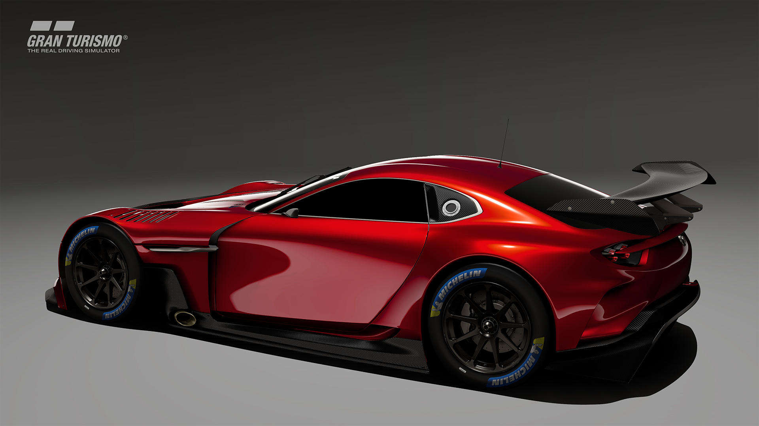

Main features of the RX-VISION GT3 CONCEPT
- Taking advantage of the original vehicle's beautiful long nose and short deck form, the GT3 Concept goes one step further by employing a wider tread
- Front midship engine and transaxle rear-wheel drive configuration achieves an ideal 48:52 front / rear weight distribution.
- Excellent aerodynamic characteristics are optimised for handling performance and tyre management.
- Powertrain features a Skyactiv-R 4-rotor engine that generates a maximum output of 570 PS¹.
- Double wishbone front and multi-link rear suspension.
- Within Gran Turismo Sport it is a certified FIA GT3 vehicle, or category Gr.3 - for conceptual models with similar specifications and performance.

Mazda rx-vISION gt3 CONCEPT MAJOR SPECIFICATIONS
Overall length × overall width × overall height |  | 4,590mm × 2,075mm × 1,120mm
Wheelbase |  | 2,700mm
Front and rear tread |  | 1,720mm / 1,760mm
Vehicle weight |  | 1,250kg
Front and rear weight distribution |  | 48:52
Engine type |  | Skyactiv-R naturally aspirated 4-rotor engine
Displacement |  | 2,600cc
Maximum output |  | 570 PS at 9,000 rpm
Maximum torque |  | 540 Nm at 7,500 rpm
Drive system |  | Front engine / rear wheel drive (FR)
Tires and wheels |  | Michelin 310/700-18

- MAZDA RX-VISION GT3 CONCEPT DESIGN STORY
The RX-Vision GT3 Concept is a co-creation of Mazda's designers and Polyphony Digital's digital modellers. The original Mazda RX-Vision was selected as the 'Most Beautiful Concept Car of the Year' in the 33rd Festival Automobile International held in France in January 2016, and has been highly praised globally.
This GT3 Concept design project began in the autumn of 2019. A sketch was released at the world final of the FIA Gran Turismo Championship held in Monaco in November of the same year, where it was announced that the vehicle would be added to the 2020 update of Gran Turismo SPORT. Thereafter, Polyphony Digital and Mazda Design together honed first the design and then the modelling work.
The RX-Vision GT3 Concept complies with the FIA GT3 rules and performance requirements for race cars. While the original cabin and door shape are maintained in accordance with GT3 vehicle regulations, the front and rear tyre treads have been expanded and fender width increased.
The vehicle is also equipped with a large bonnet air outlet that improves both aerodynamic performance and engine bay cooling, a front lower spoiler that controls cooling performance and downforce, and a rear spoiler and under diffuser that increase rear downforce and maximise rear wheel traction. The front projection area was minimised, and both the ride height and overall vehicle height were reduced in order to optimise aerodynamics.
Weight reduction and a lower center of gravity were accomplished through the removal of unnecessary interior parts and the replacement of heavy materials. An ideal 48:52 front-rear weight distribution was also achieved. Painstaking attention to cockpit ergonomics place an emphasis on ease of operation during a race. In particular, the steering wheel uses a special design that improves operability.
The interior layouts of all Mazda models are developed to offer superior ergonomics and have earned the cars a deserved reputation for their driver focused cockpits. Similarly, the RX-Vision GT3 Concept prioritises aspects such as seat shape, driving position, pedal placement and visibility during driving as essential items. Whether road car or virtual race car, All Mazdas share the philosophy of being human-centered.
Similar to mass production vehicle development, the RX-Vision GT3 Concept began with design sketch work for each component, followed by 3D digital modelling, and then completion of a detailed final design. This Gr.3 virtual race car, designed to achieve a high level of competitiveness, was made possible through Polyphony Digital's state-of-the-art modelling technology.

MESSAGE FROM CHEF DESIGNER NORIHITO IWAO
We set out to design the fastest and most aestheticalyy pleasing GT3 race car in the world, based on the FR-sport concept Mazda RX-Vision that was crowned the 'Most Beautiful Concept Car of the Year' in France in January 2016.
Focusing particularly on the exterior, we sought to eliminate waste, and pursue functional beauty. Developing a design with soul is not only essential for both concept and mass-produced cars but was also integral for this virtual race car. On this project, Mazda’s exterior and interior designers worked together with Polyphony Digital’s digital modellers to build this car.
The human-centered development concept is common to all Mazda vehicles, beginning right from the initial design stages. From the directors downwards, there are countless car lovers at Mazda’s Design Headquarters, many of whom are closely acquainted with motorsports and the Gran Turismo series. So design work progressed in consultation with these individuals as to how the car should perform and be operated during races, while at the same time envisioning how it would actually run on the race track.
Balancing the beauty of its appearance with its function and performance as a race car, while at the same time satisfying all the regulations, was like trying to thread a needle. I truly want to thank all those at Polyphony Digital who shared our aspirations and met our numerous revision requests.
Ultimately, we were able to create this RX-Vision GT3 Concept, which embodies our ideal conception of a vehicle in the virtual world and will be the car to beat in Gran Turismo SPORT. I hope that everyone around the world will enjoy driving it.
Norihito Iwao
Mazda RX-Vision GT3 Concept Chief Designer
Mazda Motor Corporation Design Division Advanced Design Studio
Norihito Iwao joined Mazda in 1993 as an exterior designer for the CX-5, CX-3, and has also worked on show cars, concept cars, etc. While he was stationed at Mazda Design Studio in North America for 3 years from 2012, he was in charge of the LM55 VISION’s conceptual work. After that, he served as chief designer for the Mazda RX-Vison (2015), the Mazda Vision Coupe (2017) and the RX-Vision GT3 Concept.
- GRAN TOURISMO SPORT
Gran Turismo is a driving simulation game series developed by Polyphony Digital for Sony Interactive Entertainment’s PlayStation®. The first game was released as a CD-ROM in 1997 and, as the platform became more powerful and increased its connectivity, it became possible to race against other players online. The latest release, Gran Turismo SPORT, is exclusively for online use.
Famous sports cars from all over the world appear in the Gran Turismo series. Approximately 150 different car models are included in categories ranging from compact road cars to super cars, to racing cars, and even luxury cars that are not typically considered within the scope of motorsports. Many concept cars, exclusive Gran Turismo vehicles and prototype machines that have been developed by car makers and tuning companies are also included.
The circuits built into the game include fictional tracks and city courses, along with existing race tracks whose characteristics have been accurately reproduced with advanced digital technology. These include the 24 Hours of Le Mans' Circuit de la Sarthe, Germany’s Nürburgring, Monaco’s renowned F1 city street course, and the UK’s Silverstone circuit. From the United States there is the Indianapolis Speedway, the venue for the Indianapolis 500, along with other famous circuits such as Laguna Seca Raceway in California. Japanese tracks featured in the game include the Fuji Speedway, Suzuka, Autopolis, Twin Ring Motegi and Tsukuba circuits.
Gran Turismo SPORT features steering, acceleration, brake, and stability control, along with other advanced driving assistance functions that enable anyone, young or old, to be able to enjoy the game. Furthermore, the game allows the driver to change the set-up of the chosen vehicle, including tyre selection, ABS and traction control settings, and independent suspension adjustments such as vehicle height and spring strength.
This level of realism sees numerous professional drivers who compete in the 24 Hours of Le Mans and Nürburgring using Gran Turismo SPORT for simulated practice before going into the actual race. It is not uncommon today for car manufacturers to use Gran Turismo to implement driver development programs that produce real race car drivers. It can be said that Gran Turismo SPORT is not only a platform for young gamers to play at home but is a full-fledged racing simulator for honing real sports driving skills that can be transferred into the real world.
- FIA GRAN TURISMO CHAMPIONSHIP
There are a number of global Gran Turismo SPORT users with outstanding driving skills who are active as sponsored professional players. The FIA (Fédération Internationale de l'Automobile) has taken note of the high level of competition in Gran Turismo SPORT and has certified the Gran Turismo Championship as an official FIA World Championship since the 2018 season.
Mazda has now become an official partner to this championship that anyone can participate in using the 'Sport Mode' option for Gran Turismo SPORT on PS4®. Players who participate in the on-line race series held annually in each region - Europe, North America, Asia, Oceania, and Latin America - and finish at the top of the autumn (northern hemisphere) rankings will be certified as 'Star Players'.
Star Players must be over 18. Those selected will have the opportunity to participate in a world tour, wherein top ranking players from all over the world come together and compete at venues throughout the globe, including in Europe and the United States. This competition consists of a 'Nations Cup', in which participants both represent their country and participate individually, and a 'Manufacturer Series' wherein drivers race on behalf of a specific brand.
A total of 12 teams, including official partners such as Mazda, along with top manufacturers from around the globe can participate in the Manufacturer Series world tour. 25 manufacturers participated in 2019.
Mazda is hoping to increase the number of players participating in the Manufacturer Series using the RX-Vision GT3 Concept and, through this, assemble excellent players to compete in the World Series and then enter the World Finals as Mazda representatives. Winning teams in the World Final will be honored at the FIA Prize Giving Ceremony scheduled to be held in Monaco in December 2020.
- GRAN TURISMO AND MAZDA

History of collaboration between the Gran Turismo series and Mazda
Mazda sports cars that were featured in the first 1997 PlayStation® Gran Turismo included the Eunos Roadster, the Eunos Cosmo, and the Enfini RX-7. As the PlayStation® platform evolved and the Gran Turismo series grew, the number of Mazda vehicle models included increased.
In Gran Turismo 4 (PlayStation®2) released in 2004, the Cosmo Sports - Mazda's first rotary engined vehicle - was included for European international races, and from Gran Turismo 5 (PlayStation®3) released in 2010, the Mazda 787B - the first Japanese car to take overall victory at the 24 Hours of Le Mans - was featured. Furthermore, a Mazda 787B 'stealth model' - an imaginary model with carbon black bodywork - was made available for a limited time in January 2011.
The collaboration between Mazda and the Gran Turismo series has deepened even further since 2014. At the request of Gran Turismo’s developer, Polyphony Digital, Mazda participated in the Vision Gran Turismo project, which saw the involvement of automobile manufacturers from all over the world.
The Mazda LM55 VISION Gran Turismo is a virtual LMP1 prototype racing car created by Mazda designers. It was released for download as a Christmas present for Gran Turismo fans and Mazda fans all over the world. This game-only model utilised Kodo -Soul of Motion design and paid its respects to the Mazda 787B. It was envisioned as 'a model that will aim to conquer the 24 Hours of Le Mans in the future.
A 1/1 full-sized model of this virtual race car was produced and, at the 2015 Goodwood Festival of Speed (UK) in which Mazda acted as the host brand, placed alongside the Mazda 787B show car atop the spectacular central sculptural feature in front of Goodwood House, creating a truly unforgettable sight for all those who attended.
The MAZDA6 Gr.3 - which is based on the MAZDA 6 Skyactiv-D that made its debut in the American Grand-Am GX series in 2013 - has been modified according to FIA GT3 regulations and appears in Gran Turismo SPORT. Since 2018, many Japanese players have competed in the FIA Gran Turismo Championship using this model.
- MAZDA MOTORSPORTS HERITAGE
Mazda has long been recognised as a brand active in motorsports, especially in Western markets. The high-speed performance of the Wankel rotary engine (RE), which was first commercialised in a Japanese car in 1967, demonstrated durability and reliability, and Mazda itself participated in many endurance races from the late 1960s to the early 70s to display its high level of performance. The RE Mazda 787B became the first Japanese car to take overall victory in the 1991 24 Hours of Le Mans (France). The rotary engine’s reputation of having exceptional performance is known throughout the world.

RE race car European expeditions
Not long after the 10A rotary engine-equipped Cosmo Sport was launched on the market, Mazda participated in the 1968 Marathon de la Route at the Nurburgring in Germany. In their first entry into this challenging race, in which it was said to be difficult just to reach the finish line, the Mazda car finished 4th overall, leaving a strong impression on European motorsport officials.
From 1969, the Familia Rotary Coupe (export name R100 Coupe) was used in touring car races across Europe. In the 1970 24 Hours of Spa Francorchamps in Belgium, Mazda - which entered four Familia Presto rotary coupes - saw one of their cars more than hold its own against the European powerhouse teams, leading the race for almost 20 hours before ultimately falling back due to technical troubles. This saw it dubbed the 'Little Giant' for its capacity to give the most prominent teams a run for their money, and cemented its place in the European market.
In 1981, the Mazda UK and Mazda Factory supported TWR Racing (UK) team entered a first-generation RX-7 in the 24 hours of Spa-Francorchamps, and achieved the first ever overall victory for a Japanese car in the history of the race.

Success in JAPANESE races
From 1971, Mazda, which had gained confidence through its European campaigns, decided to focus on competition in touring car races - the most popular category in Japan at the time. The immediate task at hand for the Mazda works team was to defeat rival cars equipped with in-line 6 cylinder 2.0L DOHC engines that were considered unbeatable.
After the relatively small Capella Rotary Coupe and Savanna took victories seemingly without breaking a sweat, subsequent touring car races became the almost exclusive province of Mazda RE cars. With fewer components, ease of tuning for more power, excellent durability and low running costs, RE-equipped Mazda cars were an easy-to-use proposition for young and talented racing drivers.
A large proportion of the young drivers who propelled Japanese motorsports into the modern age from the 1980s onwards entered touring car races as privateers driving Savannas. Among these drivers, many achieved excellent results in international races in their later careers, including in Formula 1 races and the 24 Hours of Le Mans. In 1976, the Savanna set a record of 100 wins in the Fuji TS touring car race series.
Along with touring car races, RE cars also attracted many drivers in the Fuji Grand Champion (GC) series. With Mazda contract drivers such as Yoshimi Katayama, Yojiro Terada, and Takashi Yorino joining the GC series, the company was able to make various technical breakthroughs that would later be useful in the development of Group C cars competing in the 24 Hours of Le Mans.

RE whirlwind that blew through the IMSA
In the early 1970s, Mazda RE vehicles introduced to the North American market were hit by the oil cisis that occurred shortly thereafter, resulting in sluggish sales. However, the first RX-7 (known as the Savanna RX-7 in Japan) released in March 1978 — a 2+2 sports car with slant nose styling that fully utilised the unique characteristics of RE vehicles — broke through the slump, making a huge splash at the IMSA’s (International Motor Sports Association) renowned 24 Hours of Daytona, which set it apart from the competition.
The Mazda Works Team and Mazda North America debuted two IMSA GTU (2.0L or less sports car) specification RX-7s at Daytona in 1979 and achieved a remarkable 1-2 finish in the GTU class. The news spread throughout the United States almost instantly, and not only did numerous amateur racers choose the RX-7, but also a large number of influential teams and tuners in the US began competing for victory by tailoring the RX-7 to race specifications.
As a result, the RE vehicles’ dominated the IMSA series. From 1980, the RX-7 took the IMSA GTU category series championship for 8 consecutive years. It also took the IMSA GTU class victory for 12 consecutive years at the 24 Hours of Daytona between 1982 and 1993. Furthermore, in 1990, an RX-7 GTO mounted with a 4-rotor engine recorded the 100th IMSA win for a single model.

THE 24 Hours of Le Mans Challenge
In 1970, a Mazda RE equipped car took on the challenge of racing in the renowned 24 Hours of Le Mans, regarded by many to be the pinnacle of endurance races in the world. A Belgian private team entered a Chevron B16 Mazda that mounted a 10A rotary engine amidships in a commercial prototype chassis, but early in the race they were forced to retire due to technical issues.
In 1974, Mazda Auto Tokyo, a Japanese dealer team, competed with a two-seater open sports car mounted with a 12A rotary engine. However, they encountered consecutive issues and were unable to complete the race.
Using these early disappointments as a catalyst, Mazda’s official team, Mazda Auto Tokyo (which would later become Mazdaspeed) developed a vehicle modified from the first-generation RX-7, and returned to Le Mans again in 1979. However, the task would not prove easy, and they had to wait until 1982 for their first race completion.
When Mazdaspeed was officially launched the following year, the newly developed prototype car, the Mazda 717C, took Group C Junior class victory at Le Mans in 1983.
While a three-rotor engine had been under development by Mazda since 1986, the team began entering race cars mounted with 4-rotor engines in the 24 Hours of Le Mans in 1988. In 1989, three 4-rotor engine mounted vehicles took 7th, 9th, and 12th overall places, demonstrating the high reliability of Mazda RE cars. However, overall victory still remained elusive.
Meanwhile, an extremely ambitious command was issued from the executive leading Mazda's development department at the time, stating: 'Our goal is take overall victory at Le Mans'. This led to numerous performance improvement proposals being gathered from several development engineers. In this way, the Mazdaspeed and Mazda teams formed one racing unit and put all their efforts into development of one race car.
The fruit of this labour was the Mazda 787B. And at the 1991 24 Hours of Le Mans - the last year the RE was able to compete at Le Mans due to changes in vehicle regulations - the 787B completed the race without issue and became the first Japanese car to take overall victory at this most prestigious of endurance races.

Mazda Motorsports continues to thrive in North America
The turn of the century saw Mazda North America reignite the flame of Mazda Motorsports, which had temporarily lost some momentum. Against a background of the RX-7’s success and the rise of the Spec Miata series (competed with the MX-5), an RX-8 GT equipped with a 20B 3-rotor engine was entered into the Grand-Am series, which now included the renowned 24 Hours of Daytona. The RX-8 GT took GT class victory at the Daytona race in 2008 and 2010.
Riding this wave of success, the number of RX-8 GTs in competition gradually increased, and for a time made up the majority of vehicles in their class in 2010. The car went on to take the Grand-Am GT Series championship. However, after production of the RX-8 ceased in 2012, the car was withdrawn from the series and, instead, a Mazda 6 equipped with a Skyactiv-D diesel turbo engine made its debut. This vehicle became the 2013 Grand-Am GX class champion.
In 2014, the Grand-Am series was integrated with the American Le Mans series, and so Mazda North America began competing in the prototype category of the IMSA’s newly established United Sports Car Championship (USCC), the top category of the series.
From 2015, the team competed with vehicles equipped with 2L in-line 4-cylinder turbo engines. And when new vehicle regulations came into effect for the 2017 season, they entered the newly developed Mazda RT24-Ps that incorporated Kodo - Soul of Motion design. In 2019, while racing in the IMSA WeatherTech Sports Car Championship held throughout the United States, the team achieved their first victory. Going on to take three consecutive victories thereafter, they cemented their place amongst the top competing teams.
- Major Mazda vehicles that appear in the Gran Turismo series
- Mazda Cosmo Sports
- Mazda RX-7 (2nd generation)
- Mazda RX-7 (3rd generation)
- Mazda MX-5 Roadster (4th generation)
- Mazda 787B
- Mazda LM55 VISION
- Mazda6
- Mazda6 Gr.3

- CONTACTS
Countries | Contacts | Telephone
Europe  Mazda Motor Europe GmbH  www.mazda-press.com | John Rivett  jrivett@mazdaeur.com | +49 160 3354 786
Austria  Mazda Austria GmbH  www.mazda-press.at | Iris Schmid  iris.schmid@mazda.at | +43 463 3888 226
Albania  Mazda Central and  South East Europe | Ivana Mudrovčić  mudrovcic@mazda.hr | +385 1 6060 264
Belarus  Atlant-M Holpy | Elena Bolotnikova  elena_bolotnikova@atlantm.com | +375 172 189 906
Belgium  Mazda Motor Belux  www.mazda-press.be | Peter Gemoets  gemoetsp@mazdaeur.com | +32 3 860 66 05
Bosnia & Herzegovina  Mazda Central and  South East Europe | Ivana Mudrovčić  mudrovcic@mazda.hr | +385 1 6060 264
Bulgaria  Mazda Central and  South East Europe | Ivana Mudrovčić  mudrovcic@mazda.hr | +385 1 6060 264
Croatia  Mazda Motor Croatia  www.mazda-press.com.hr | Ivana Mudrovčić  mudrovcic@mazda.hr | +385 1 6060 264
Cyprus  Mazda Cyprus  A.Stephanides & Son  Automotive Ltd | Liza Pieridou  l.pieridou@gpa.com.cy | +357 22 581 254
Czech Republic  Mazda Motor Czech Republic  www.mazda-press.cz | Markéta Kuklová  mkuklova@mazdaeur.com | +420 739 681 120
Denmark  Mazda Motor Danmark  www.mazda-press.dk | Jannik Olsen  jolsen@mazdaeur.com | +45 43 25 21 06
Finland  Inchcape Motors Finland Oy | Sampo Salovuori  sampo.salovuori@inchcape.fi | +358 50 572 6000
France  Mazda Automobiles France S.A.S.  www.mazda-presse.fr | David Barrière  david.barriere@mazda.fr | +33 1 61 01 65 95
Germany  Mazda Motors (Deutschland) GmbH  www.mazda-presse.de | Jochen Münzinger  jmuenzinger@mazda.de | +49 2173 943 220
Hungary  Mazda Motor Hungary KFT  www.mazda-press.hu | Eszter Burovinc  burovinc@mazda.hu | +36 1 464 5007
Rep. of Ireland  Mazda Motor Ireland  www.mazda-press.ie | David Bannon  dbannon@mazdaeur.com | +353 86 348 8635
Italy  Mazda Motor Italia S.r.L  www.mazda-press.it | Erika Giandomenico  egiandomenico@mazdaeur.com | +39 06 60 297 800
Luxemburg  Mazda Motor Belux  www.mazda-press.lu | Peter Gemoets  gemoetsp@mazdaeur.com | +32 3 860 66 05
North Macedonia  Mazda Central and  South East Europe | Ivana Mudrovčić  mudrovcic@mazda.hr | +385 1 6060 264
Malta  GasanZammit Motors Ltd. | Sarah Kennard  skennard@mps.com.mt | +356 2569 72 06
Moldavia  Mazda Central and  South East Europe | Eszter Burovinc  burovinc@mazda.hu | +36 1 464 5005
Montenegro  Mazda Central and  South East Europe | Ivana Mudrovčić  mudrovcic@mazda.hr | +385 1 6060 264
Netherlands  Mazda Motor Nederland  www.mazda-press.nl | Jur Raatjes  jraatjes@mazdaeur.com | +31 182 685 080
Norway  Mazda Motor Norge  www.mazda-press.no | Petter Chr. Grüner Brinch  pbrinch@mazdaeur.com | +47 66 81 87 81
Poland  Mazda Motor Poland  www.mazda-press.pl | Szymon Soltysik  ssoltysik@mazdaeur.com | +48 223 181 980
Portugal  Mazda Motor de Portugal Lda  www.mazda-press.pt | Sandra Ferro  sferro@mazdaeur.com | +351 21 351 2774
Romania  Free Communication | Daniel Amzar  daniel.amzar@freecomm.ro | +40 21 20 74 740
Russia  Mazda Motor RUS  www.mazda-press.ru | Maria Maguire  mmaguire@mazdaeur.com | +7 499 500 4856
Serbia  Mazda Central and  South East Europe | Ivana Mudrovčić  mudrovcic@mazda.hr | +385 1 6060 264
Slovakia  Mazda Motor Slovak Republic  www.mazda-press.sk | Markéta Kuklová  mkuklova@mazdaeur.com | +420 739 681 120
Slovenia  Mazda Motors Slovenia (MMS d.o.o.)  www.mazda.si | Dimitrij Vušnik  dimitrij.vusnik@mazda.si | +386 1 420 40 89
Spain  Mazda Automóviles España S.A.  www.mazda-press.es | Natalia García  ngarcia@mazdaeur.com | +34 91 418 5468
Sweden  Mazda Motor Sverige  www.mazda-press.se | Johan Lagerström  jlagerstrom@mazdaeur.com | +46 300 31 810
Switzerland  Mazda (Suisse) SA  www.mazda-press.ch | Giuseppe Loffredo  gloffredo@mazda.ch | +41 22 719 3360
Turkey  Mazda Turkey  www.mazda-medya.com | Tamer Atsan  tatsan@mazdaeur.com | +90 216 430 7040
Ukraine  AUTO International | Julia Sivak  sivak@auto-intl.kiev.ua | +380 442 30 15 04
United Kingdom  Mazda Motors UK Ltd.  www.mazda-press.co.uk | Graeme Fudge  gfudge@mazdaeur.com | +44 1 322 622 691

#Mazda
#RXVision
#DriveTogether

For more information please visit the Mazda Press Portal
www.mazda-press.com

Participatory motorsports supported by Mazda: In Japan the "Roadster Party Race" series is flourishing. The series, which started in 2002 and continues today, is Japan's longest running one-make race and so far about 5,000 people have participated (as of May 2020, survey by Mazda). In the 2019 season a total of 120 participating vehicles entered the three series held in Northern Japan, East Japan, and Western Japan. The Roadster Party Race is a one-make series in which anyone can participate with a base grade, unmodified "Roadster NR-A” with a registration number. To ensure fairness, tires have designated sizes and brands. The vehicles are equipped with a roll cage and a full harness seat belt to ensure safety and, after the race, participants can drive home using the same vehicle, making it a car that is both convenient and sporty. Also, any contact made with other vehicles during the race results in zero points, a major feature that places significant importance on good sportsmanship. In the United States, Mazda North American Operations established a ladder system based on the Spec Miata (MX-5 one-make race) series begun in the early 1990s. The series cultivates excellent drivers from each region and advances them up into higher categories. It has attracted around 10,000 participants from across the country. The "Global MX-5 Cup," which is a one-make series for the current fourth-generation MX-5, is developing into a semi-professional category competed in circuits across America.
FIA GT3 category: The FIA GT3 category is a vehicle standard for race cars based on commercially available 2-seater or 2+2-seater sports cars modified for racing and certified by the Fédération Internationale de l'Automobile (FIA). Many car manufacturers around the world have registered GT3 standard race cars and major international race series such as the GT World Challenge, based in Europe, and the IMSA series in the United States have adopted FIA GT3 vehicles as a main competition model. Numerous exciting races see FIA GT3 cars competing including the 24 Hours of Daytona, the 24 Hours of Spa-Francorchamps, the 24 Hours of Nurburgring, the Bathurst 12-hour, the 12 Hours of Sebring, and the Suzuka 10 hours. FIA GT3 vehicles require homologation (certificates) issued by the FIA, and modifications outside the permitted range are strictly limited. Furthermore, the race organizers carry out "BoP" (balance of performance) adjustments on the vehicles, and the engine power, vehicle weight, minimum ground clearance, etc are specified in detail for each vehicle type, to ensure fairness. Gran Turismo SPORT also incorporates its own regulations in the Gr.3 category.
Output and weight may change due to balance of performance (BoP) adjustments depending on the race

