Mazda to increase engine production in Thailand
• Carmaker to triple annual capacity at Chonburi facility to 100,000 engines by 2018
• Also to add a new engine machining plant and start exports to Malaysia and Vietnam
Hiroshima / Chonburi / Leverkusen, 30 August 2016. Mazda Motor Corporation will increase annual production capacity at its engine assembly plant in Chonburi Province, Thailand from 30,000 units to 100,000 in the first half of 2018. The company also announced plans to build a new engine machining facility with a similar capacity at Mazda Powertrain Manufacturing (Thailand) Co., Ltd. (MPMT).

MPMT produces SKYACTIV-D 1.5-litre clean diesels and SKYACTIV-G 1.3 petrol engines for use in Mazda2s manufactured at the nearby Auto Alliance (Thailand) Co., Ltd. facility. The Japanese carmaker is investing ¥22.1 billion (€193 million) to increase engine capacity. The new engine machining plant, meanwhile, will enhance Mazda’s system for comprehensive production in Thailand that includes vehicle bodies, engines and transmissions. The company will add the SKYACTIV-G 2.0 to the range of powerplants produced there, and begin exporting engines to its vehicle production sites in Malaysia and Vietnam.

“Enhancing Mazda’s comprehensive production system in Thailand is a key initiative in our effort to strengthen global production,” said Masatoshi Maruyama, Mazda’s managing executive officer in charge of global production. “By increasing production capacity and starting up the new engine machining factory as scheduled, Mazda intends to further develop MPMT as its first overseas hub for engine exports, thereby improving our global production efficiency and contributing to the development of Thailand’s automotive industry.”

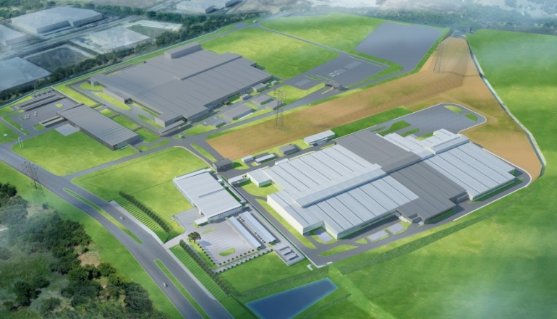
Illustration of MPMT upon completion with the transmission plant (top left) and engine plant (bottom right). Areas of the engine plant in light grey indicate the planned machining facility.

