Mazda resumes production at all Japanese plants

- Mazda production in Japan to operate on two-shift basis in July
- Production volume in Japan, Thailand and Mexico to increase 150% compared to June

Hiroshima / Leverkusen, 23 June 2020. The Mazda Motor Corporation would like to express its deepest sympathy and concern for all of those who have been suffering from the novel coronavirus outbreak and extend our condolences to the families it has impacted.

In many countries, businesses have gradually restarted operations while continuing to put in place measures to prevent the spread of the novel coronavirus. In some markets, consumer demand for cars has also begun to recover.

By carefully monitoring the demand in our markets over the past months and after a period of adjusting global production and supply, inventory levels at our plants, offshore, at ports and at our dealer outlets are steadily returning to appropriate levels. Based on the current conditions, we will resume both day and night shift operations without suspensions at all plants in Japan before the end of July. Our plants in Mexico and Thailand will continue to operate with a reduced number of working days.

As a result, after production volume in Japan was 40 percent compared to the volume produced during the previous year period, production volume for July in Japan will recover up to as much as 80 percent of its volume for the same month last year. Combined with our overseas production in Mexico and Thailand, the planned production volume in July will be 150 percent higher than the production volume in June 2020. We will continue to respond cautiously and flexibly to the ever-changing situation.

Total production volume at plants in Japan, Mexico and Thailand
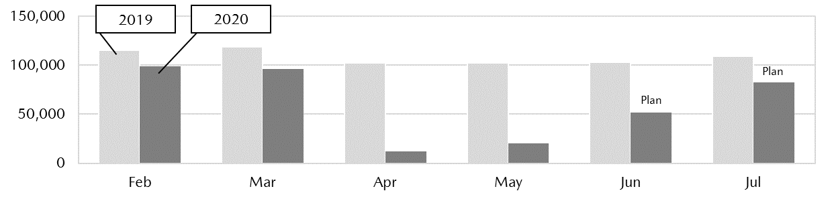

We will continue to ensure we meet our customers’ requests, while at the same time continuing to implement effective infection prevention measures.

Double shift operations resumption day for plants in Japan
To restart on July 1: Ujina Plant No. 1 and No. 2 (Hiroshima), Hofu Plant No. 2 (Hofu, Yamaguchi)
To restart on July 27: Hofu Plant No.1 (Hofu, Yamaguchi)
Note: No days with suspended operations are planned for any of the plants.

Operation days for plants in Mexico and Thailand
Mazda de Mexico Vehicle Operation (Salamanca, Guanajuato, Mexico): To operate on Monday to Thursday (from the first to fourth week)
Auto Alliance (Thailand) Co., Ltd. (Rayong, Thailand): undergoing adjustments

Note: Operations and workdays found above are as of the time of announcement and are subject to change depending on future circumstances.

END

